User Guide

This is a document about the bekeband's PD 786 Process Indicator Display.
The software version is 2.5

In cause of bad, or violent EEPROM content, you can set and load the standard EEPROM data.
This is with UP and DOWN button push at the some time in the BAD display on indicator.
The software version is 2.5
“ESC” Escape button. Usually you cat use to escape from menus, and programs.

Process Display

Main Display and Buttons.
“ENT” Enter button the anclockedge the menus, and settings.
Status LED. Red, or green light to indicate the several states, and errors.
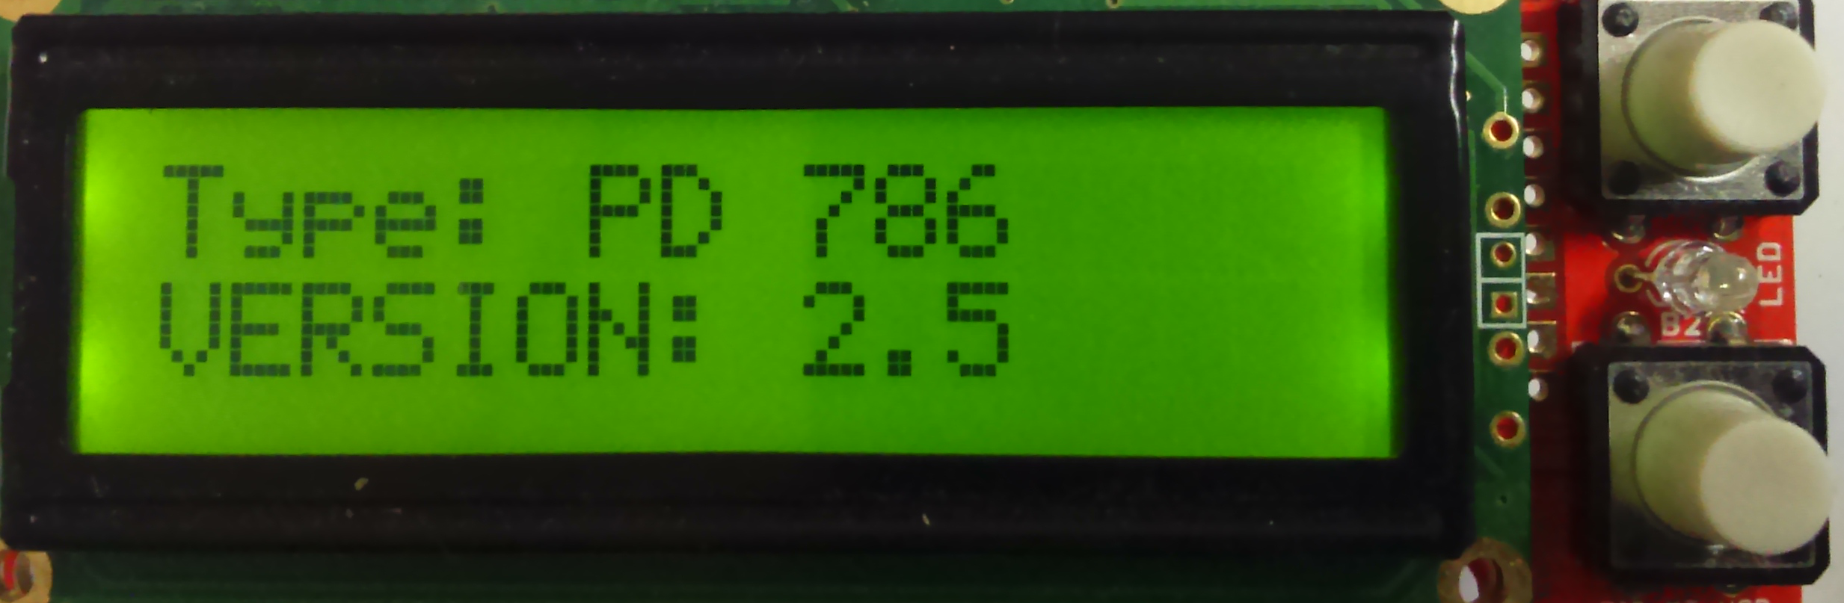1. Fig. Type, and version display.
Display area to displayed the important datas.

Version display:

After switch ON the main power will appear the type, and verion display:

Check EEPROM CRC

There are no fail
"Check EEPROM CRC"
"CRC = XXXX OK!"

Failure the CRC check.
"Check EEPROM CRC"
"CRC = XXXX BAD!"

In cause of bad, or violent EEPROM content, you can set and load the standard EEPROM data.
This is with UP and DOWN button push at the some time in the BAD display on indicator.

